PPM PROJECT

CASE STUDY ON ***RELIANCE INDUSTRIES LIMITED***

**Submitted to : Submitted by :**

**Dr. Arun Agaria sir (2019 BCS)**

1. **Nalam Anunay ( 034 )**
2. **Dasari Jayanth ( 016 )**
3. **Chaithanya Reddy ( 014 )**
4. **Nithin Kumar Reddy ( 033 )**
5. **Sai Kiran ( 037 )**
6. **Bommisetty Mahesh ( 013 )**

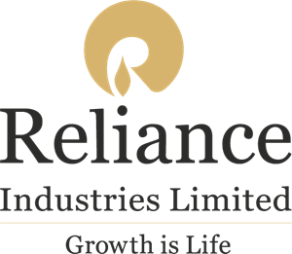

**RELIANCE AT GLANCE:**

*Realising India’s aspirations:*

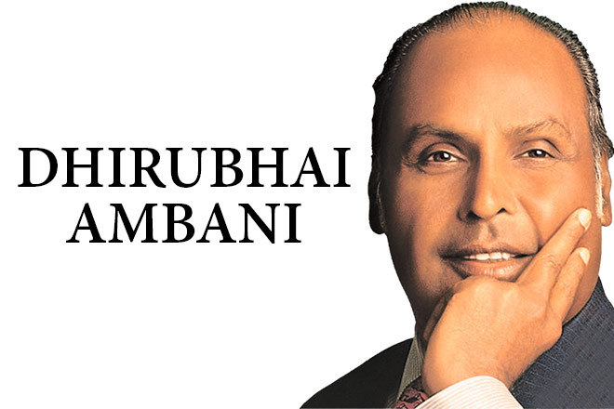RIL is India’s largest and most profitable private sector company. RIL continued to be a significant global player in the integrated energy value chain while establishing leadership positions in the retail and digital services business in India. RIL is now focussed on building platforms across its industry-leading businesses that will herald the Fourth Industrial Revolution and will create opportunities for the nation to realise its true potential.

RELIANCE IN DAILY LIFE:

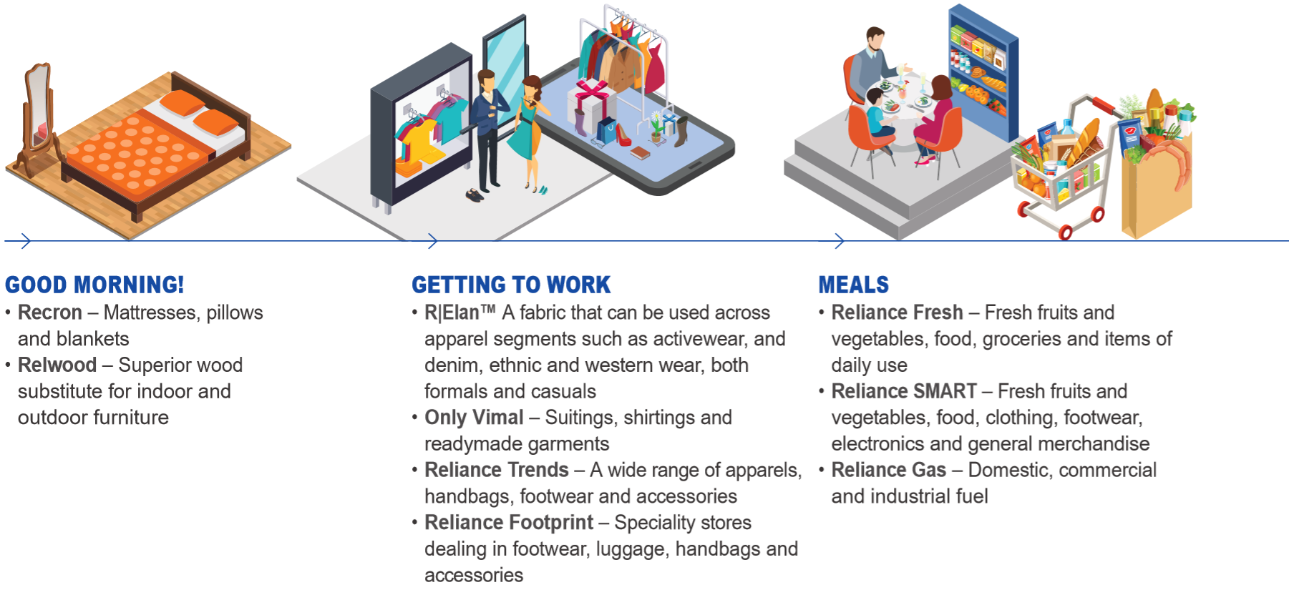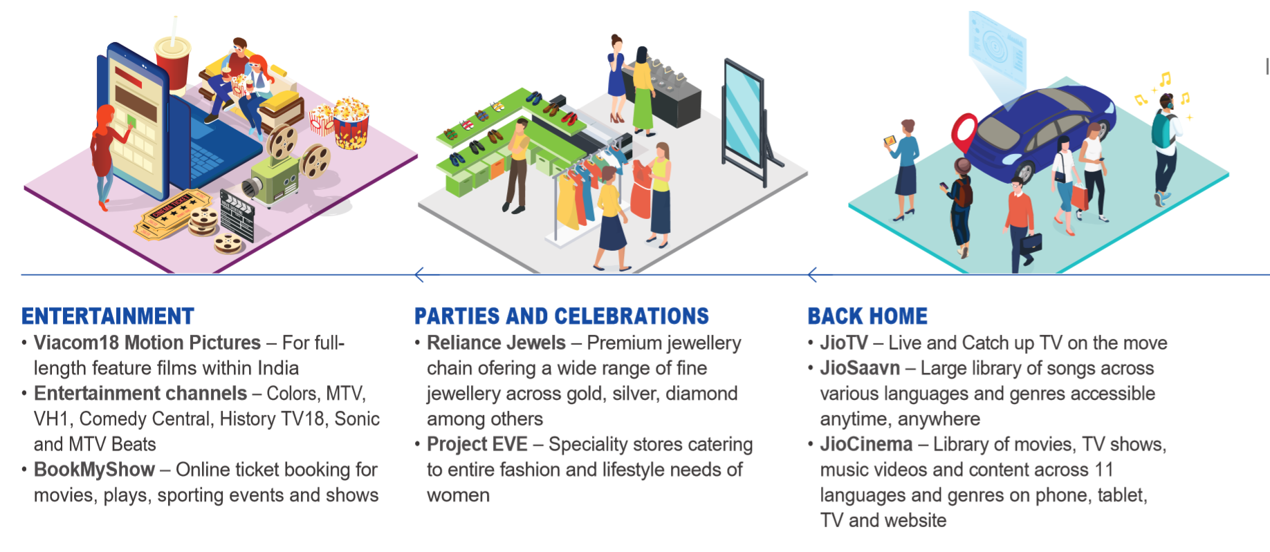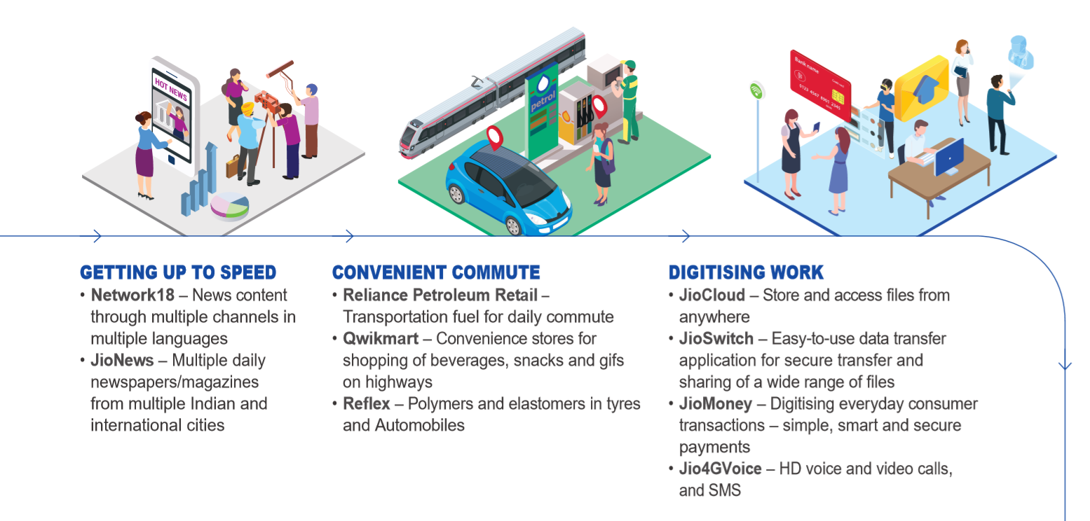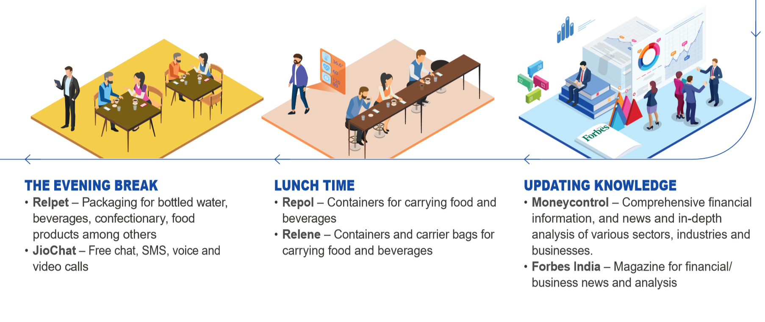

Business verticals

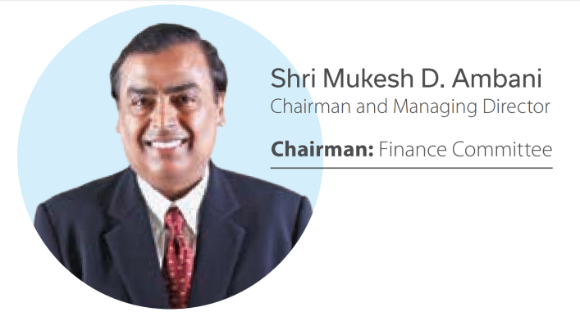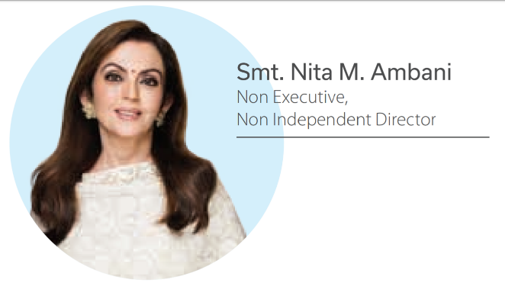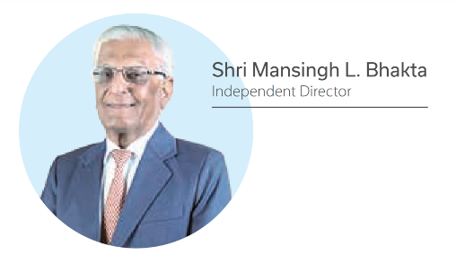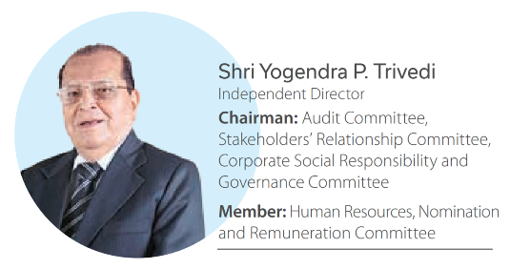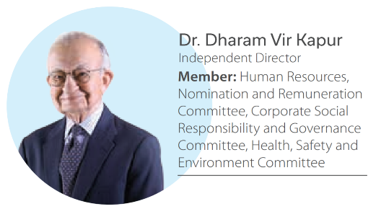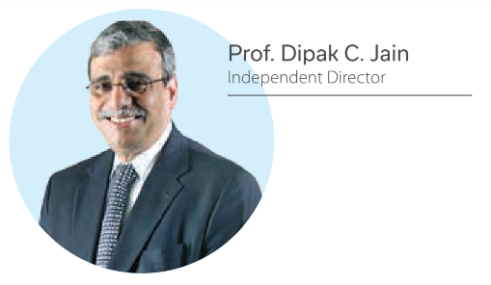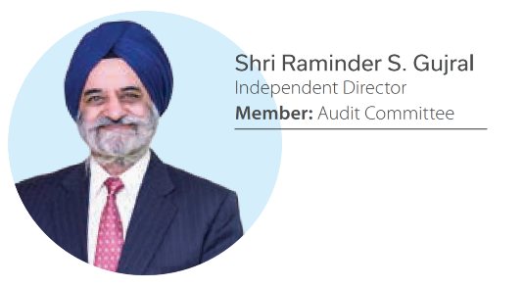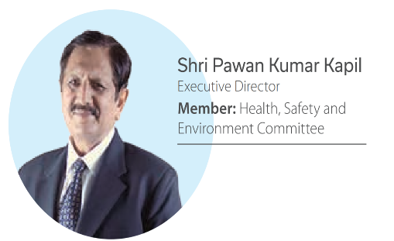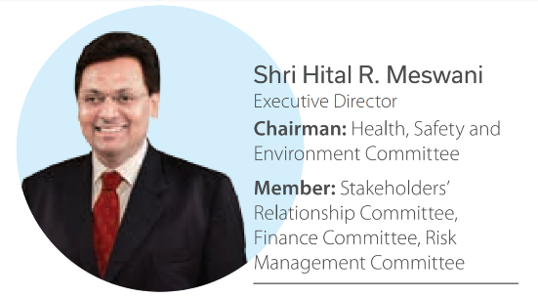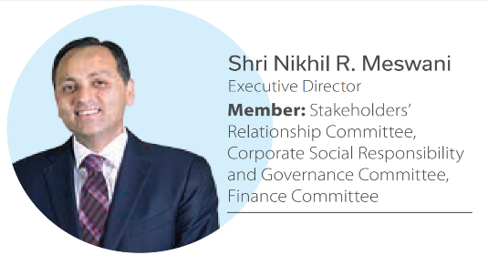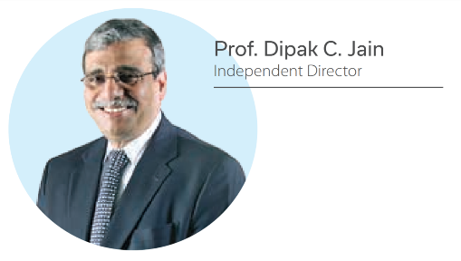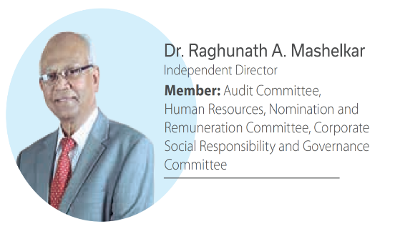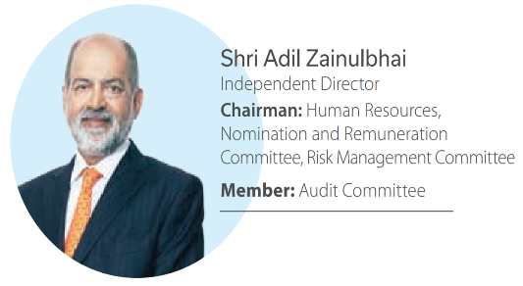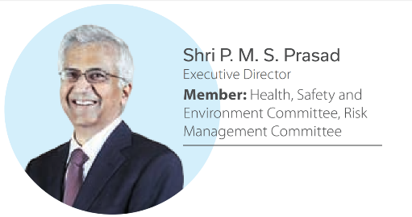

1. REFINING AND MARKETING:

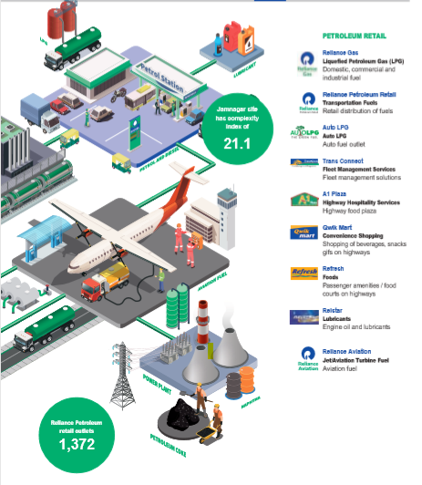 The Jamnagar manufacturing division is the world's largest refining hub. The entire refining complex was built in a record time at globally competitive capital costs – in fact, at costs much lower than comparable refineries around the world. Its scale, design, flexibility, level of automation and degree of integration heralded the way refineries of the future would be built. The speedy growth of the complex lies at the heart of India's transformation. It has transformed India from being a net importer of petroleum products to a net exporter, thereby ensuring the nation's energy security.

With crude processing capacity of 1.24 million Barrels Per Stream Day (BPSD), the Jamnagar refinery is a trendsetter and has won several awards, including the prestigious 'International Refiner Of The Year' award. It also enjoys the distinction of housing some of the world's largest units, such as the Fluidised Catalytic Cracker (FCC), Coker, Alkylation, Paraxylene, Polypropylene, Refinery offgas (ROG) cracker and Petcoke gasification plants.

Fuels from Jamnagar refinery are exported to several countries across the world. This complex refinery is future ready and can produce gasoline and diesel of any grade. Reliance also has another refinery – the sixth largest in the world – in the Special Economic Zone at Jamnagar. This refinery has a capacity for processing 580,000 BPD of crude.

Key Components of the R&M Business Model

Reliance's technical, operational and logistic strengths act as the fulcrum to leverage its refineries' asset utilisation and optimisation, the key components of the R&M business model. These strengths, coupled with our highly integrated plants and automated processes, augment our R&M business's operating efficiencies. Moreover, our refineries are strategically located on the west coast of India, offering the benefits of low transportation costs for feedstock and proximity to high-growth markets.

The goal of R&M business is to deliver industry leading returns and be a source of medium-term growth, while focusing on health, safety and environment.

#### Asset Advantage

* High production capacity ensures industry leading capital per barrel
* Dedicated marine facility, giving access to the world's largest crude and product vessels.
* Scale of operations and energy efficiency ensure the lowest operating costs, globally.

#### Asset Optimisation

* 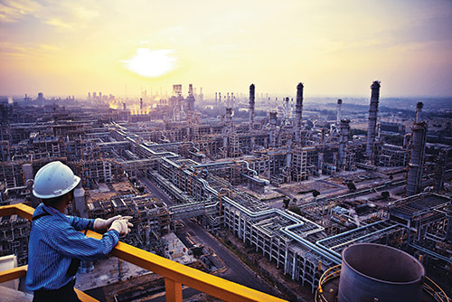Reliance's integrated Supply and Trading team works real-time with the refinery operations to optimise asset utilization
* Ability to process all grades of crude oil and meet the increasingly differentiated and more demanding product specifications.

Products:

Our refinery at Jamnagar processes a wide variety of crude oils and produces a range of petroleum products for exports as well as supply in the Indian market.

|  |  |
| --- | --- |
| PRODUCTS | APPLICATIONS |
| Liquefied Petroleum Gas (LPG) | Domestic and industrial fuel |
| Propylene | Feedstock for polypropylene |
| Naphtha | Feedstock for petrochemicals |
| Gasoline | Transport fuel |
| Jet /Aviation Turbine Fuel | Aviation fuel |
| Superior Kerosene Oil | Domestic fuel |
| High-Speed Diesel | Transport fuel |
| Sulphur | Feedstock for fertilizers and pharmaceuticals |
| Petroleum Coke | Fuel for power plants and cement plants |

PERFORMANCE:

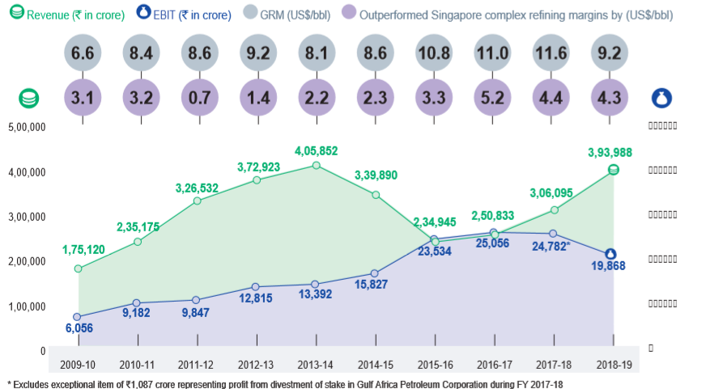

1. PETROCHEMICALS:

**Reliance Petroleum Limited** is a company owned by Reliance Industries limited (RIL), one of India's largest private sector companies. It is based in Ahemhedabad and has interests in the downstream oil business. RPL also benefits from a strategic alliance with Chevron India Holdings Private Limited (Singapore), a wholly owned subsidiary of Chevron Corporation USA (Chevron), which currently holds a 5% equity stake in the Company.

Reliance Petroleum and RIL own / have long term chartered two oil rigs - DD KG-1 and DD KG-2 (DD standing for Dhirubhai Deepwater). They are both drilling ships registered in Marshall Islands and owned by Deepwater Pacific Inc., a subsidiary of Transocean.

With an annual crude processing capacity of 1,240,000 barrels (197,000 m3) per stream day, RPL is the largest refinery in the world. It will have a complexity of 14.0, using the Nelson Complexity Index, ranking it one of the highest in the sector. The polypropylene plant will have a capacity to produce 0.9 million metric tonnes per annum.

The refinery project is being implemented at a capital cost of Rs 270,000 million being funded through a mix of equity and debt. This represents a capital cost of less than US$10,000 per barrel per day and compares very favourably with the average capital cost of new refineries announced in recent years. The International Energy Agency(IEA) estimates the average capital cost of new refinery in the OECD nations to be in the region of US$15,000 to 20,000 per barrel per day. The low capital cost of RPL becomes even more attractive when adjusted for high complexity of the refinery.

PERFORMANCE:

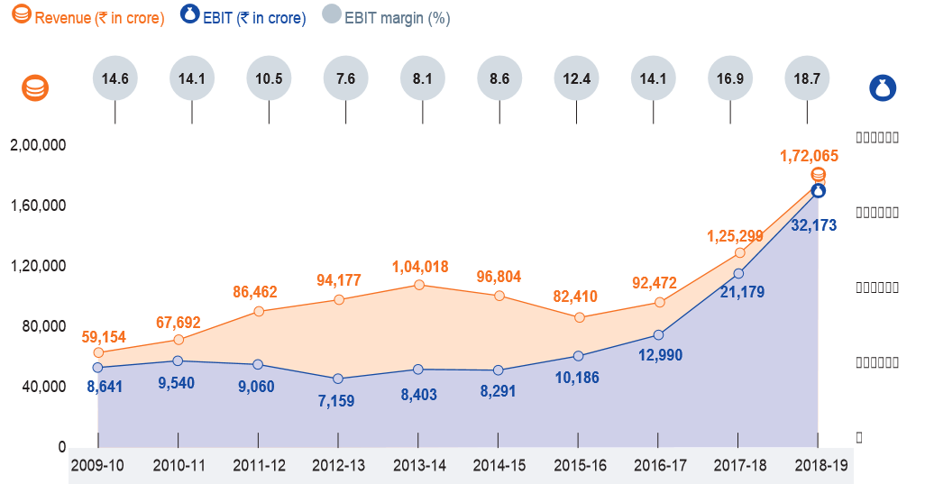

1. Oil and Gas Exploration & Production:

The Company’s oil and gas assets include KG D6, Panna- Mukta, Tapti and two CBM blocks. RIL also has two joint ventures in North American shale plays – Pioneer Natural Resources and Chevron.

Vision: Towards energy security for the nation

Mission: Our mission is to maximise stakeholders' value by finding, producing and marketing hydrocarbons and to provide sustainable growth while catering to the needs of customers, partners, employees and the local communities in which we do business. We will conduct our business in a manner that protects the environment as well as the health and safety of our employees, contractors and the local communities in which we do business.

Product flow chart:

4. RETAIL:

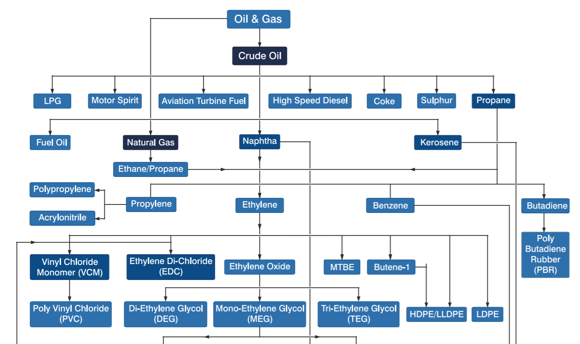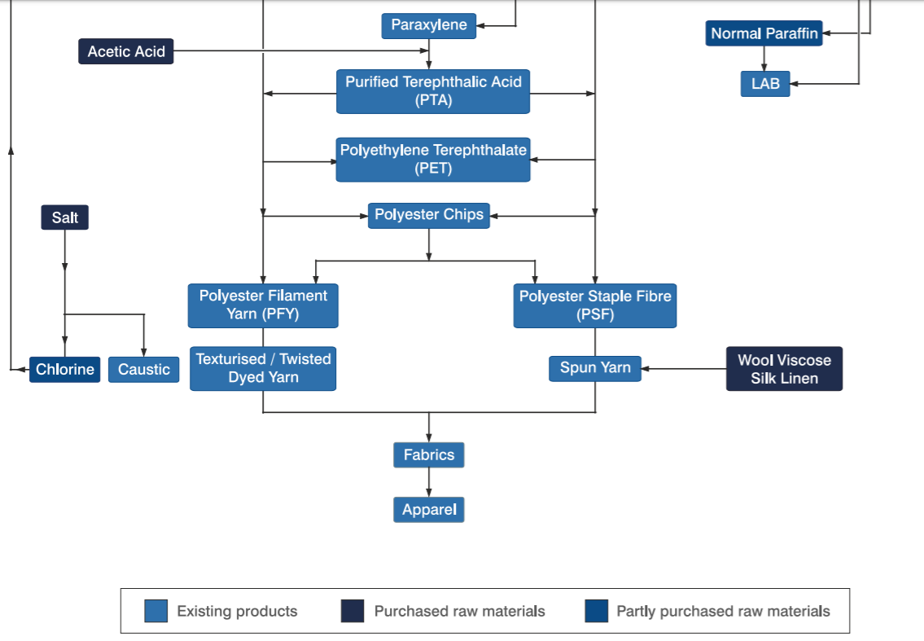

Reliance Retail became the first retailer in India to cross the `1,00,000 crore turnover milestone and is now ranked 94th in Deloitte’s Global Powers of Retailing 2019 list. Reliance Retail also crossed the 10,000 store count milestone. It has cemented its position as India’s largest retailer by revenue and profitability, delivering superior value to its customers, suppliers and other stakeholders.

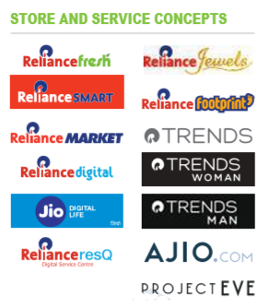

Reliance Retail’s revenue growth in FY 2018-19 was primarily driven by aggressive store addition and spurt in same-store sales. Growing at a rate of nearly 10 stores per day in the last two years, Reliance Retail witnessed one of the fastest store expansions in the world. It added a total of 2,829 stores to its tally during FY 2018-19. As on March 31, 2019, Reliance Retail operated 10,415 retail stores in over 6,600+ towns and cities, covering 22 million sq. ft. of area.

VISION: To be the most admired and successful organised retail company in India that enhances the quality of life of every Indian.

MISSION: Provide millions of customers with unlimited choice, outstanding value proposition, superior quality and unmatched experience across the full spectrum of products and service

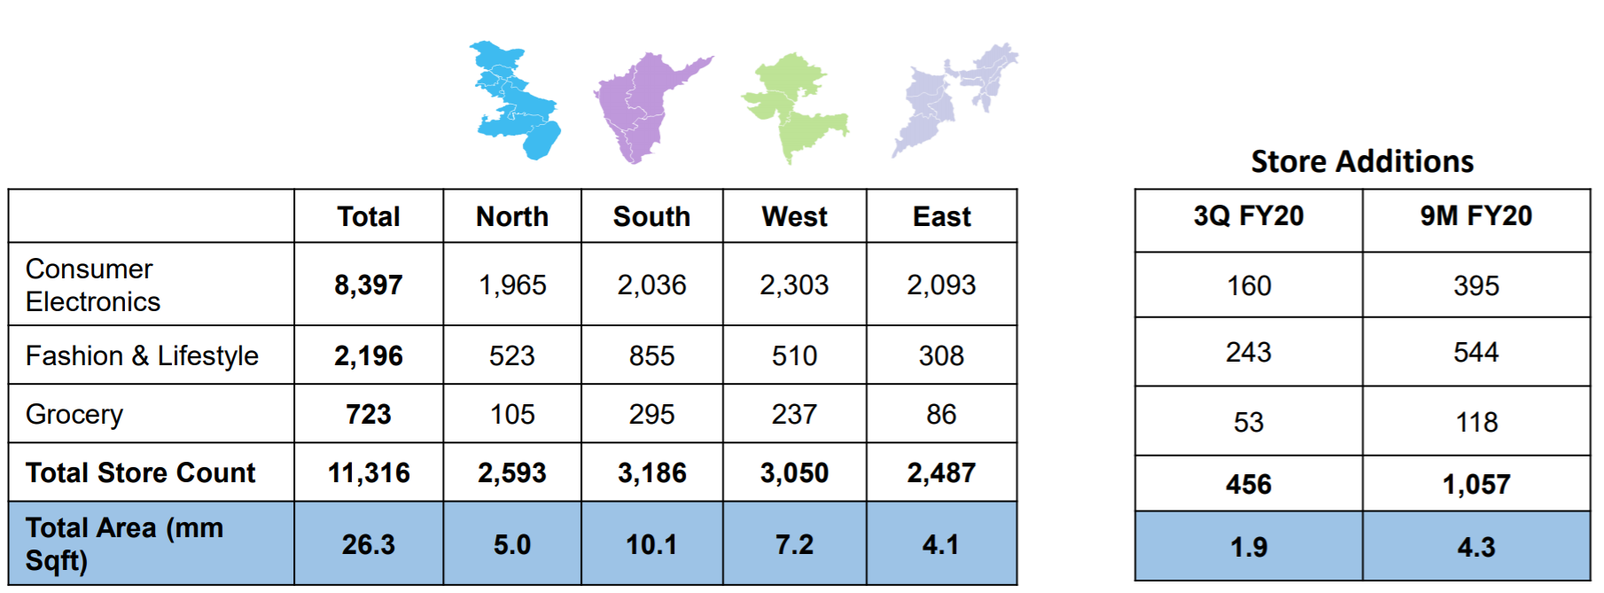

* Serve the entire spectrum of Indian society i.e., from households, kiranas and traders, to small and medium enterprises and large corporations
* Reach the length and breadth of the country through our physical and digital distribution platforms
* Generate direct and indirect employment opportunities with skill transformation and talent development on an unprecedented scale

PERFORMANCE:

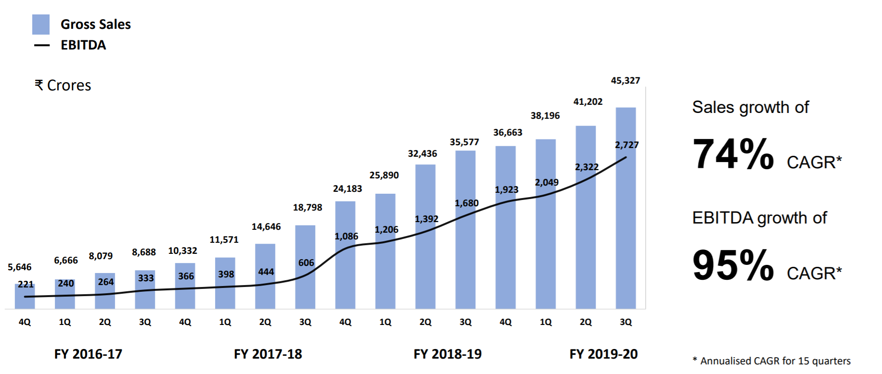

1. DIGITAL SERVICES:

Jio added an average 10 million subscribers a month and crossed the 300 million subscriber milestone this year to become the world’s fastest growing digital services company. Jio has not only revolutionised India’s telecommunication industry but also digitised its hinterlands through its extensive network penetration. Recently, Jio was recognised for its meaningful impact by being ranked #1 globally on Fortune’s 'Change the World' list. The ranking evaluates companies that use the profit motive to help the planet and make an important social impact.

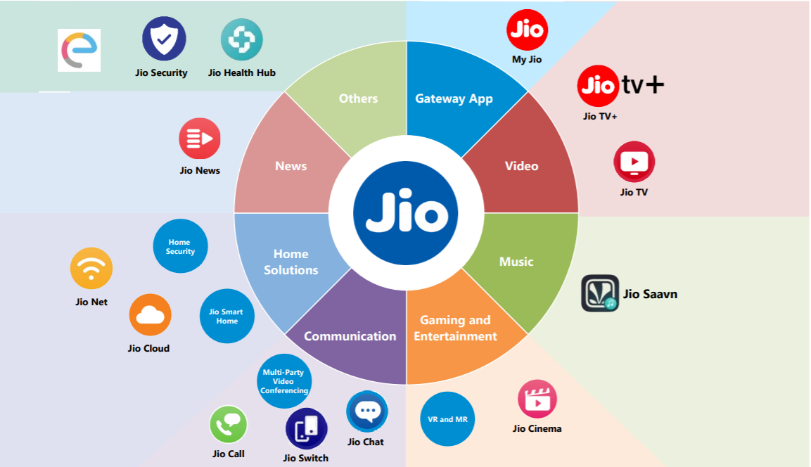

The phenomenal level of customer engagement on Jio’s platform is evident from the fact that over 3 exabytes per month of data is carried on its wireless network. Every Jio subscriber consumes on an average 10.9 GB data, 823 minutes of voice calls and 17 hours of video per month. In CY 2018, Jio carried close to 71% of the total 4G traffic of India.

It has also entered into a series of content partnerships with Disney and Star India, among others, to provide best-in-class content to its subscribers.

Wireline network connectivity in India continues to remain underserved. Jio is working towards serving the need for better connectivity with its GigaFiber services. This would include home broadband, entertainment and smart home IoT solutions. Jio, with its FTTH services, has set a target to connect 50 million homes across the country. To accelerate Jio’s commitment to connect 50 million homes with Jio’s solutions, RIL has made strategic investments in Hathway Cable and Datacom Limited and DEN Networks Limited.

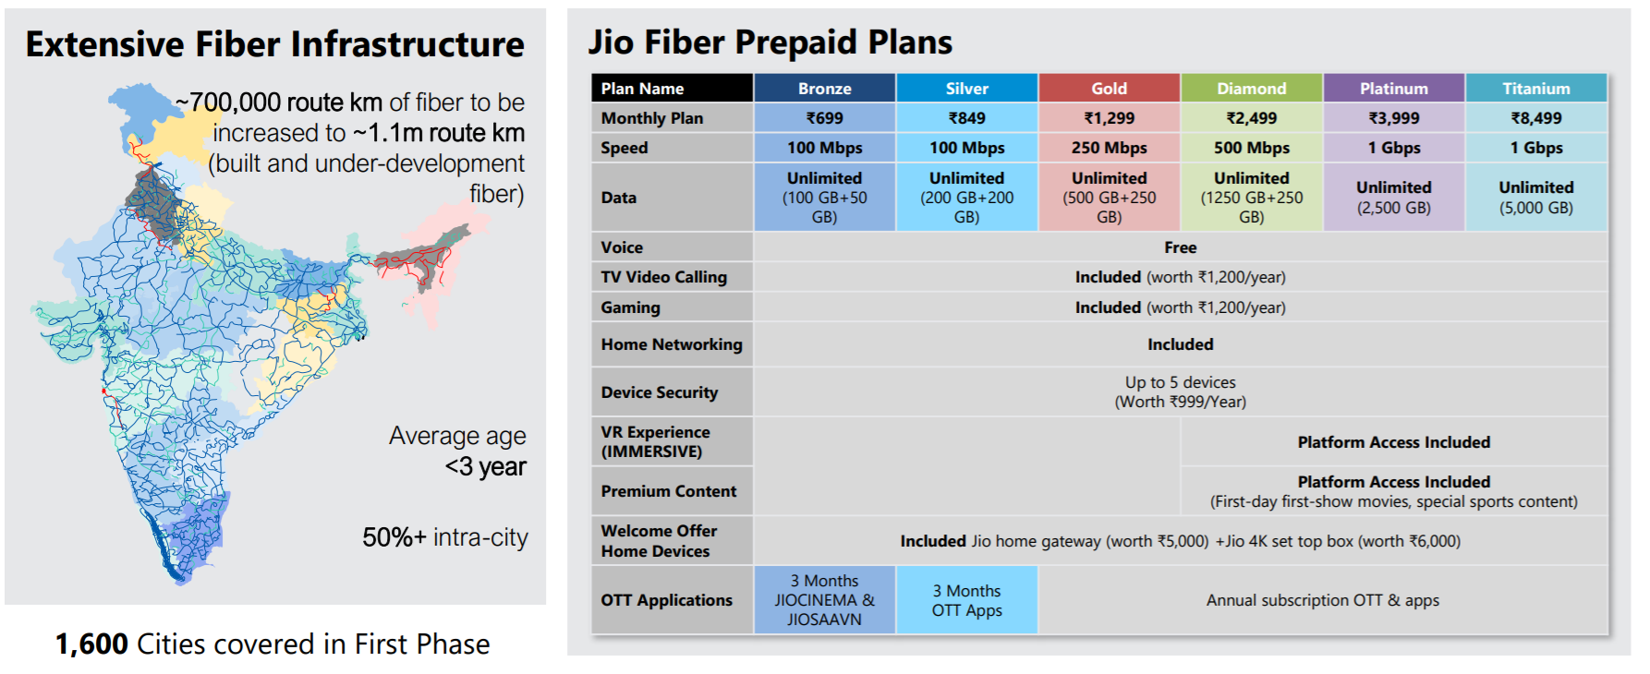

VISION: To connect everyone and everything, everywhere – always at the highest quality and the most affordable price. Jio’s vision is to transform India with the power of digital revolution

MISSION:

* Connectivity for every Indian
* Superior customer experience
* Affordable data
* Best-in-class fixed-line solutions platforms

PERFORMANCE:

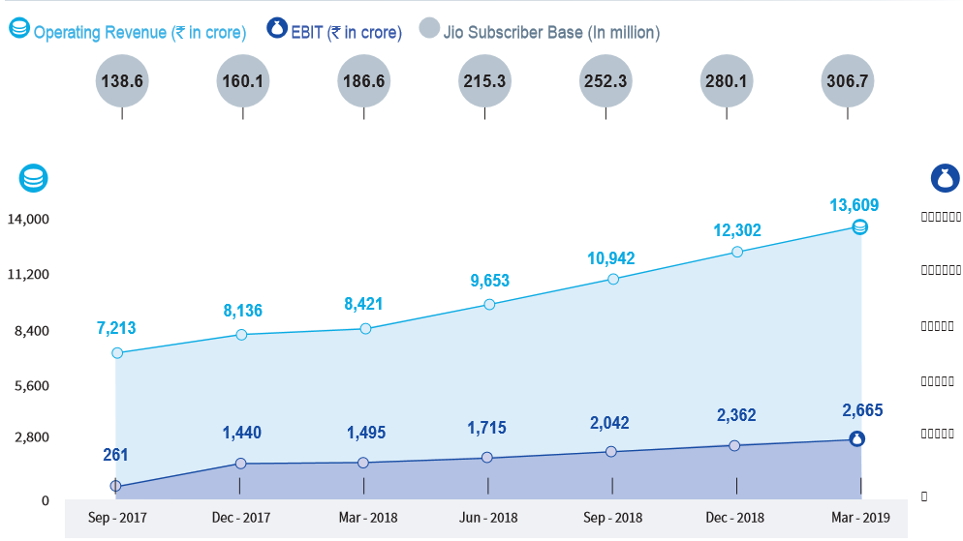

1. MEDIA AND ENTERTAINMENT:

Network18 is a media and entertainment powerhouse with its foothold in television, filmed entertainment, digital business, magazines, mobile content and allied businesses.



VISION AND MISSION:

Network18 aims to be a channel-agnostic provider of top-drawer content, across genres, regions and languages. We aim to be India’s top media house with unparalleled reach, and touch the lives of Indians across geographies and genres

PERFORMANCE:

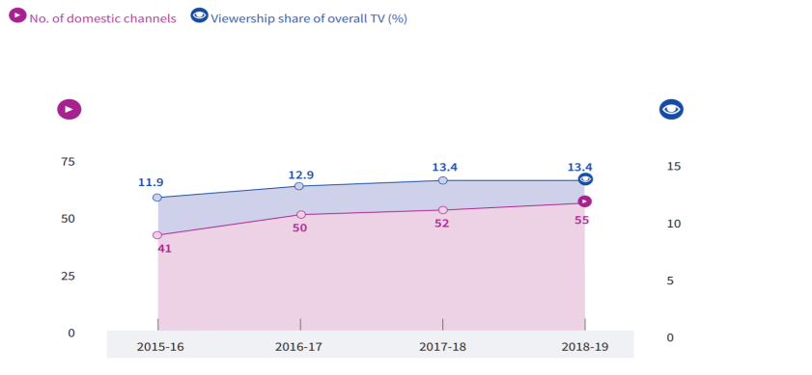

**Reliance Share Price**:

PRESENT(01/04/2020) CONSOLIDATED VALUATION:

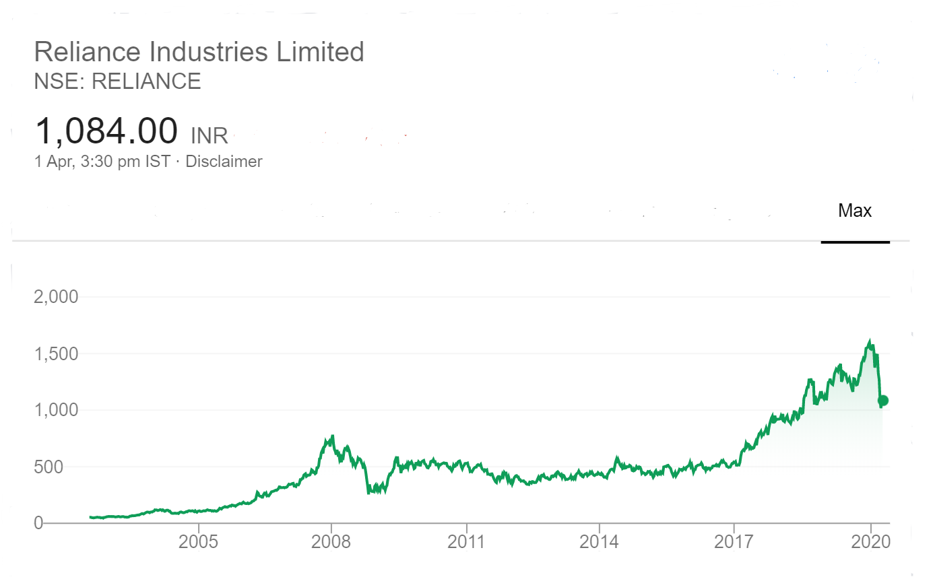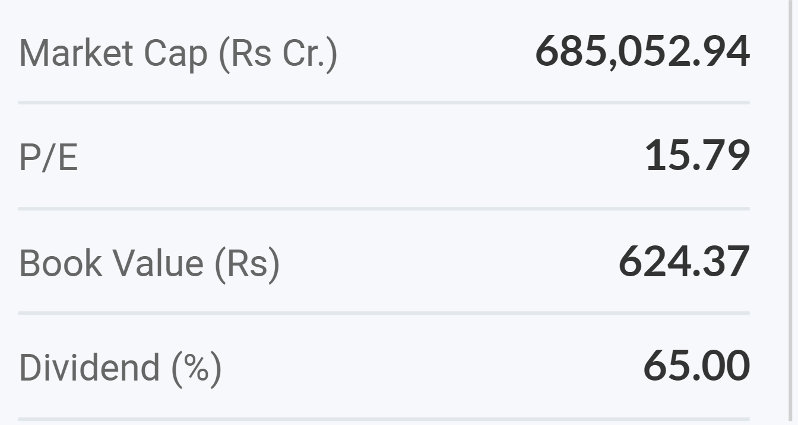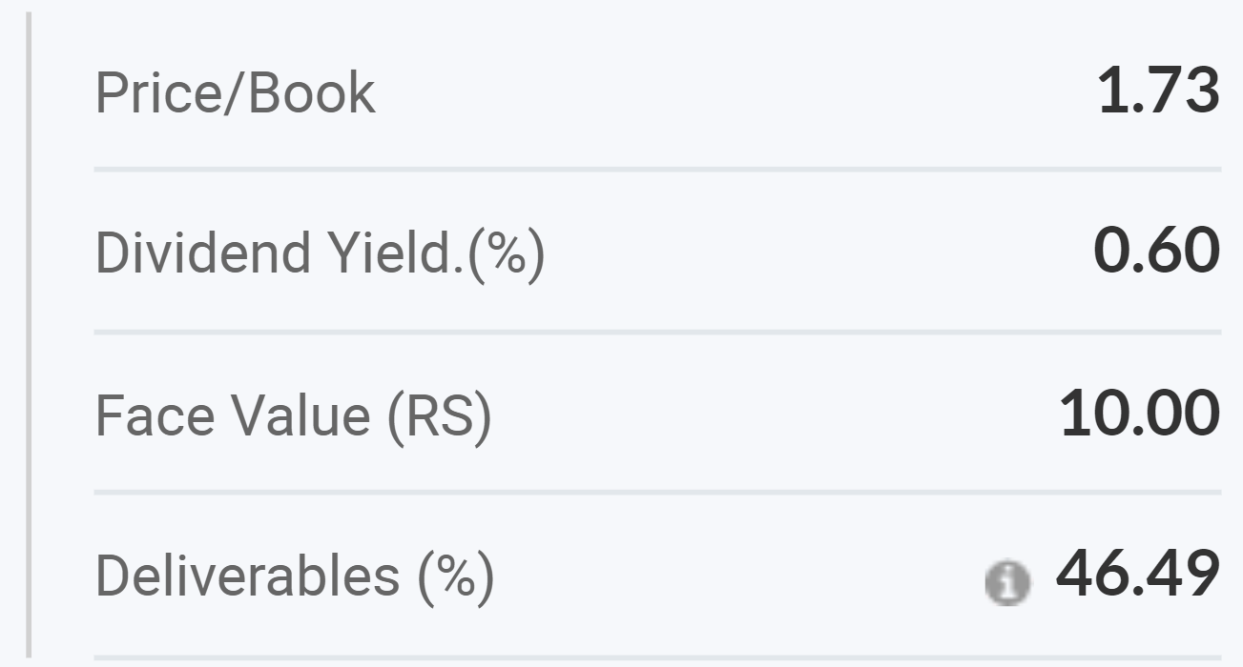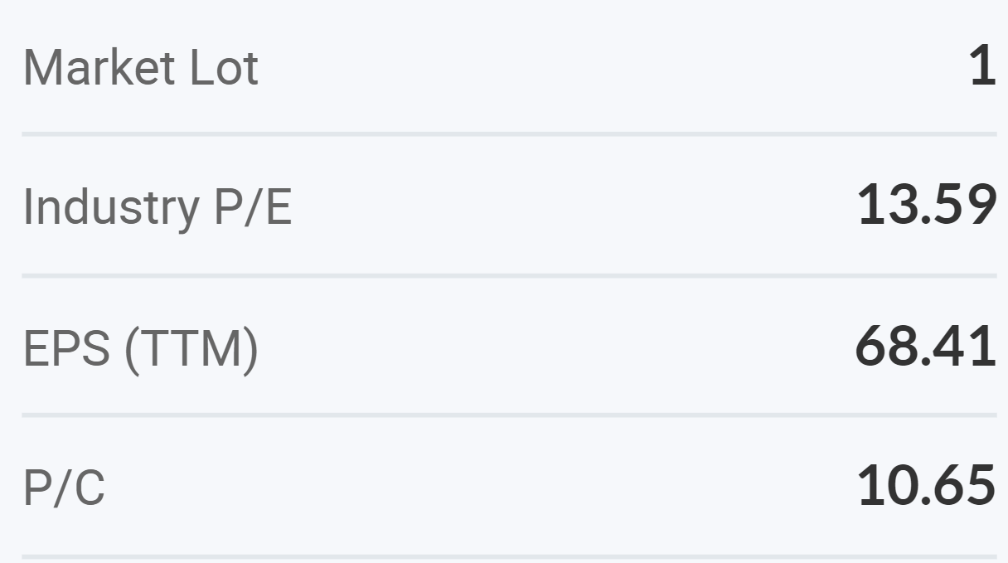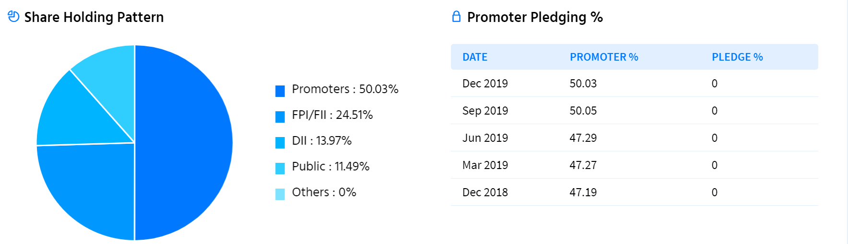

KEY PERFORMANCE INDICATORS:

Market Capitalisation : ₹8,63,996 crore(FY:2018-19)

Consolidated Turnover: ₹6,22,809 crore(FY:2018-19)

Consolidated Profit After Tax:₹39,588cr(FY:2018-19)

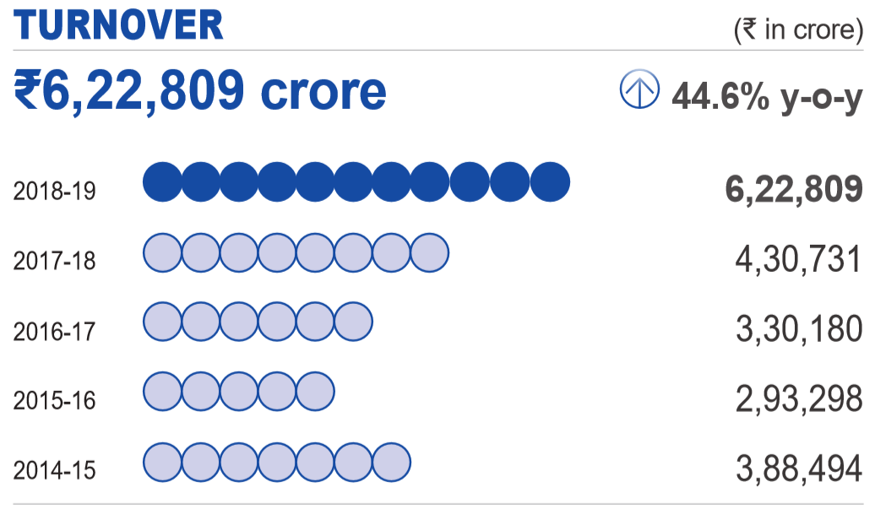 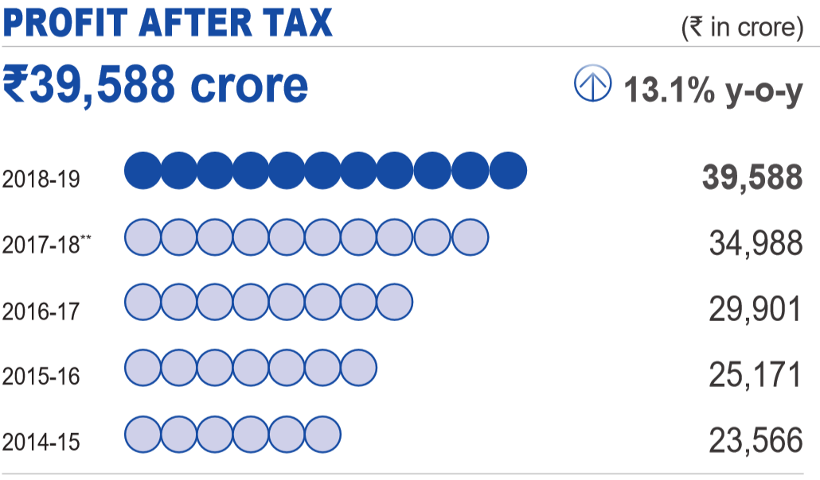

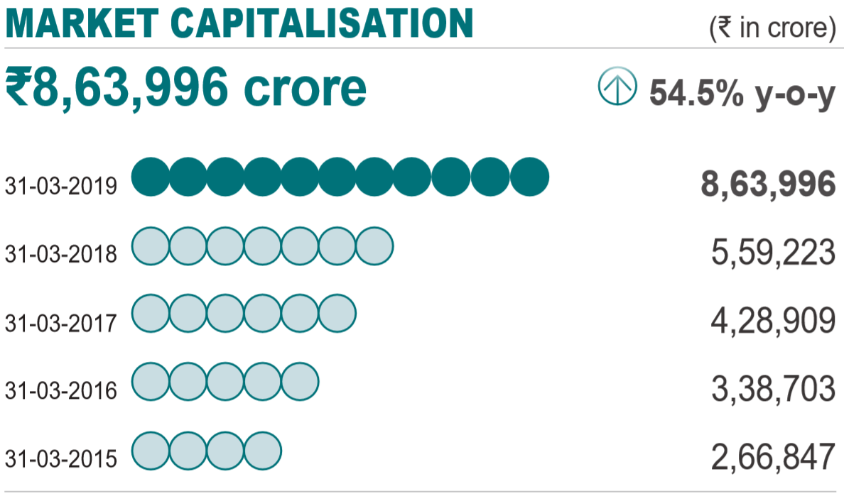 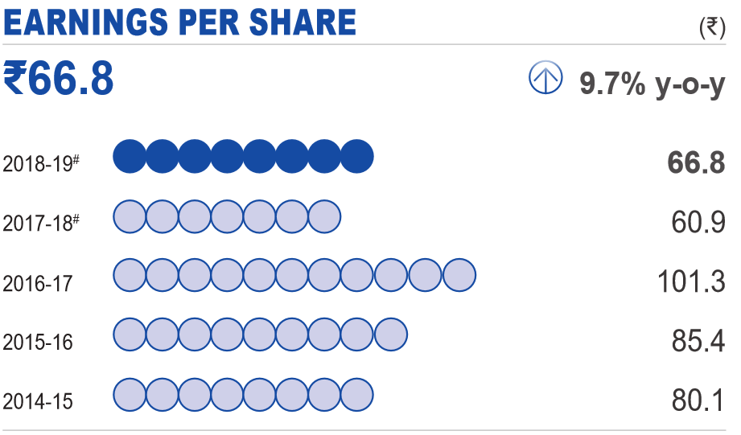

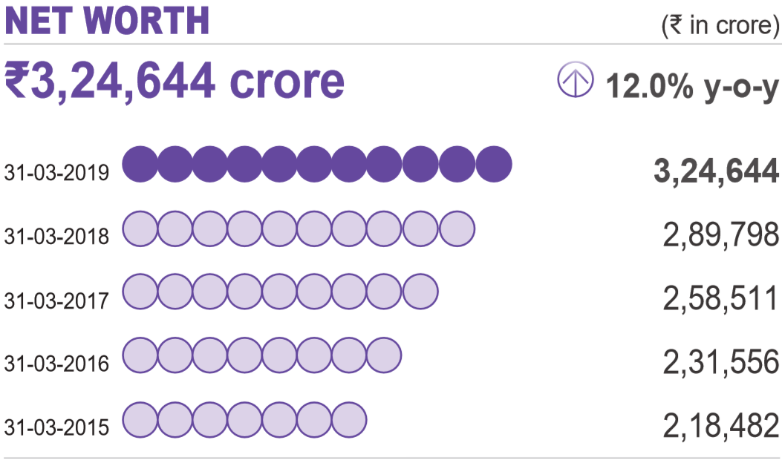 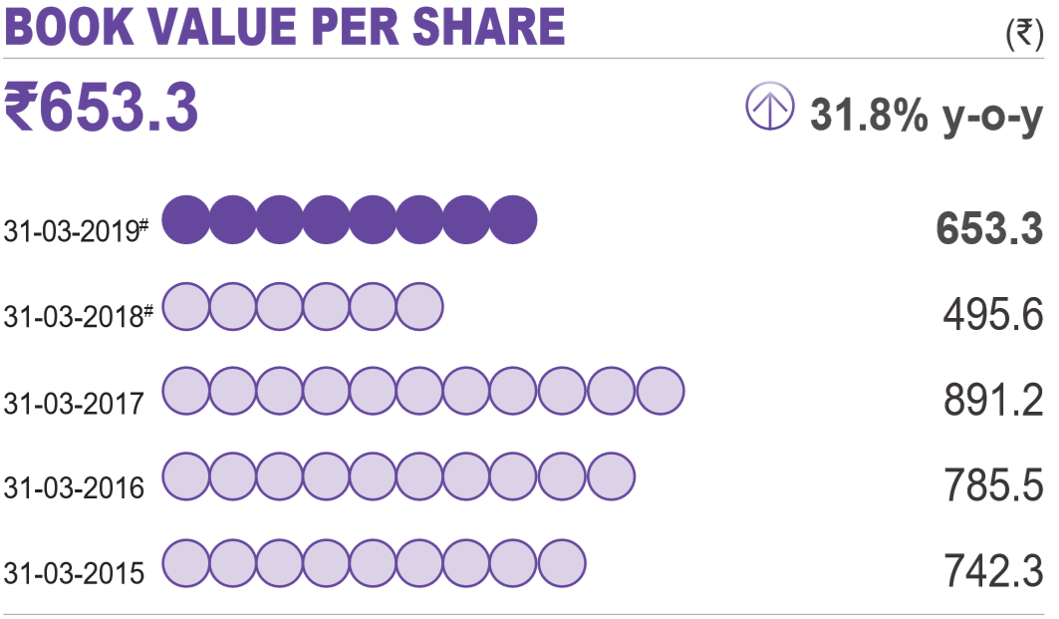

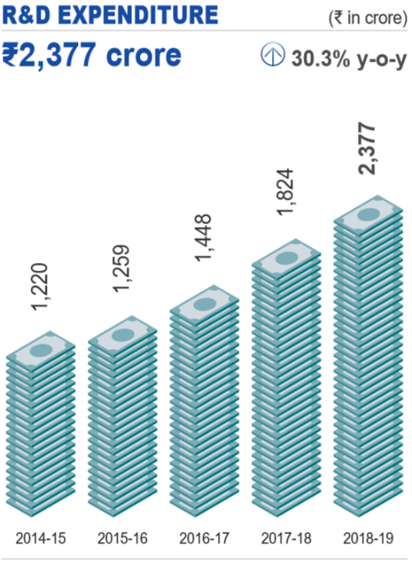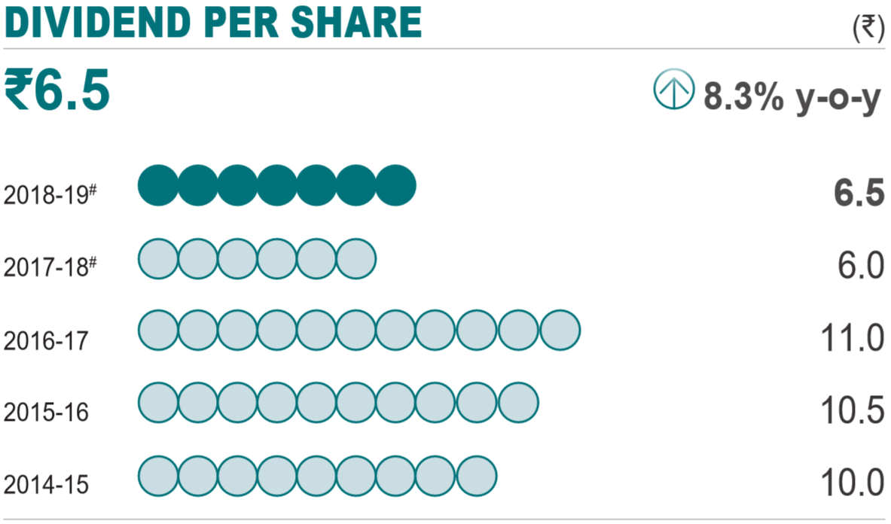 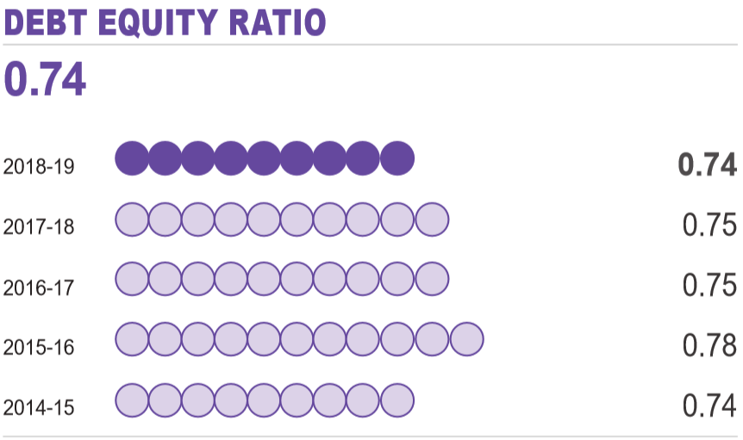

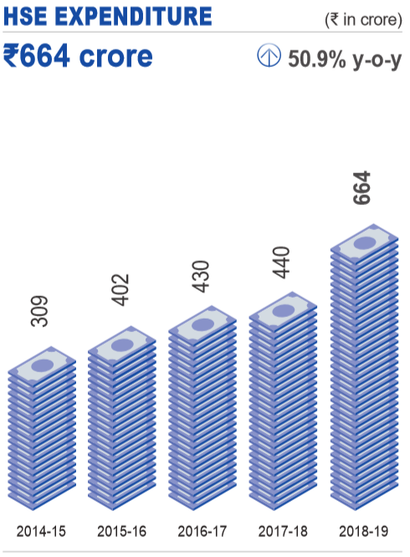

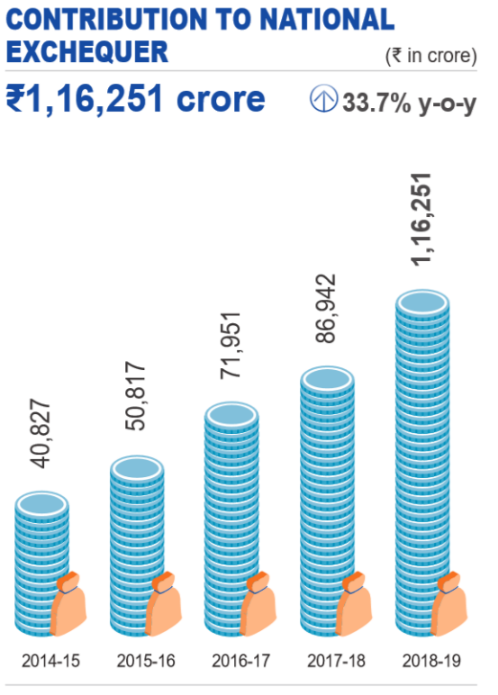

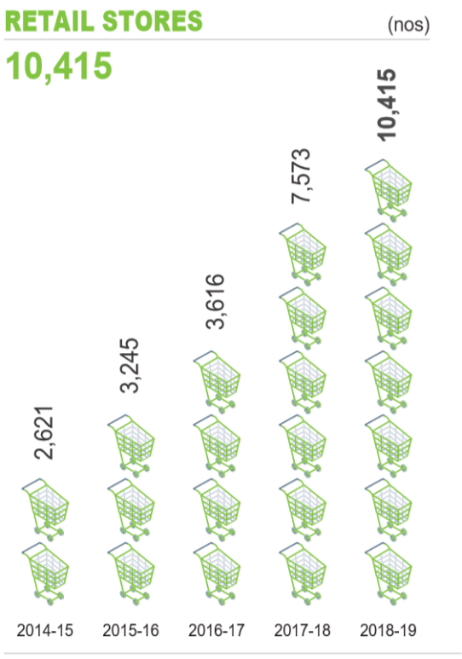

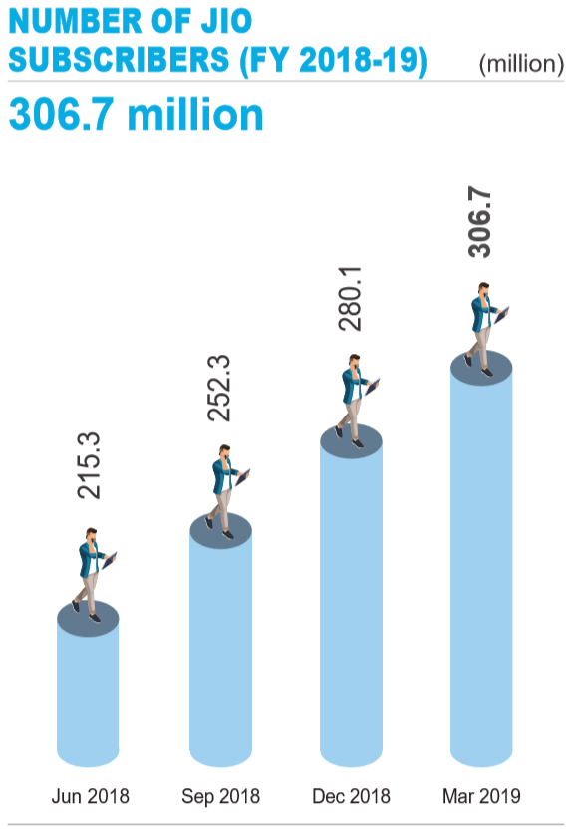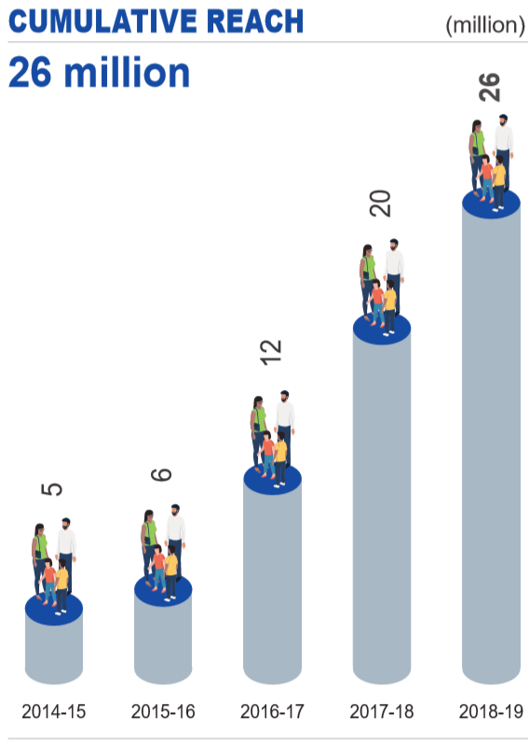

VALUE ADDED (CONSOLIDATED):

Value added is defined as the value created by the activities of a business and its employees

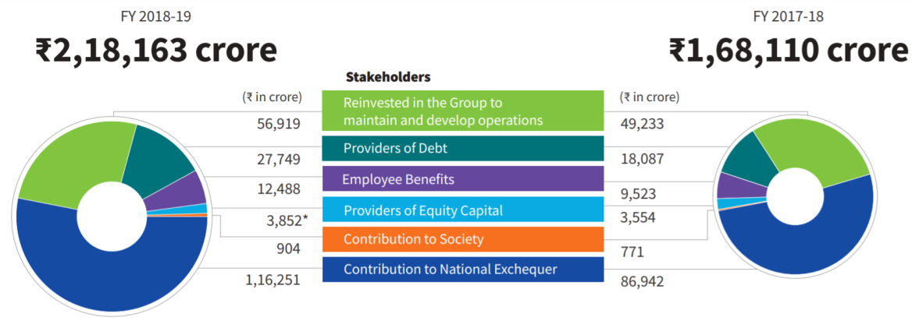

Balance Sheet Consolidated Figures in Rs. Crores :

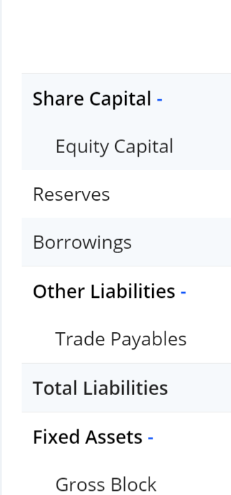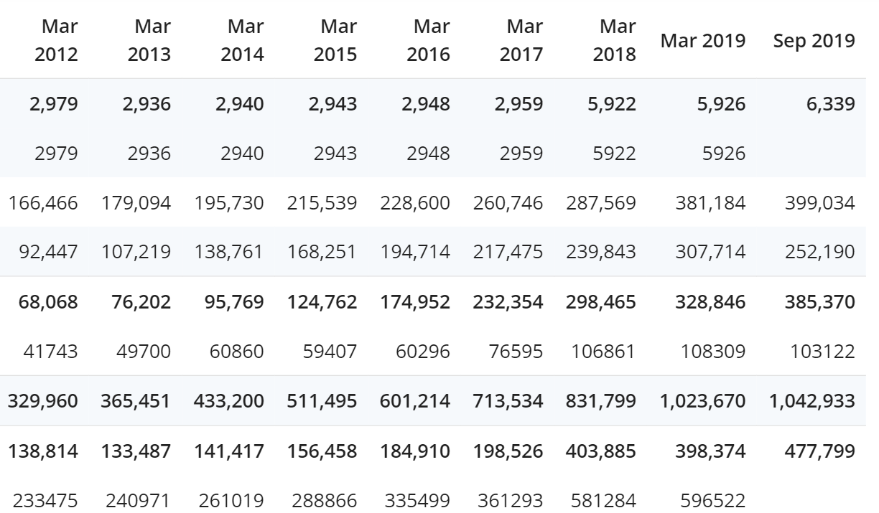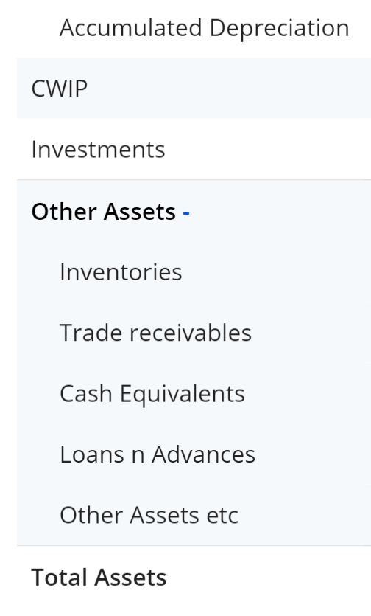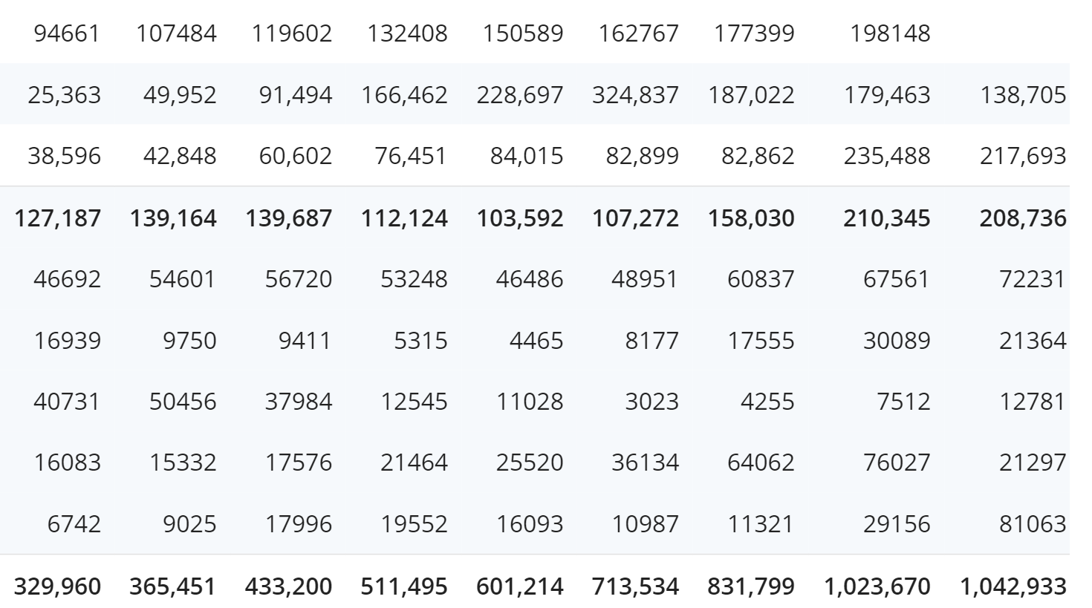

Profit & Loss Consolidated Figures in Rs. Crores:

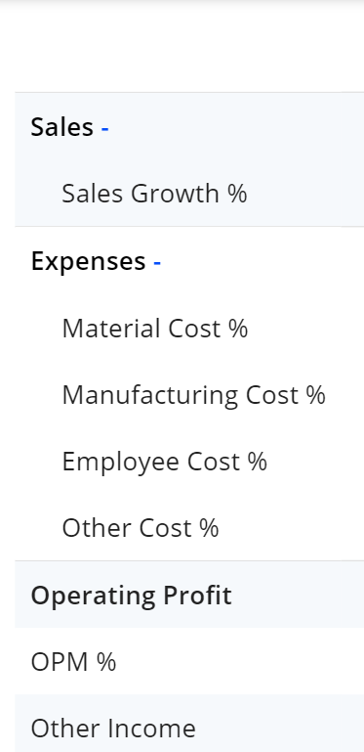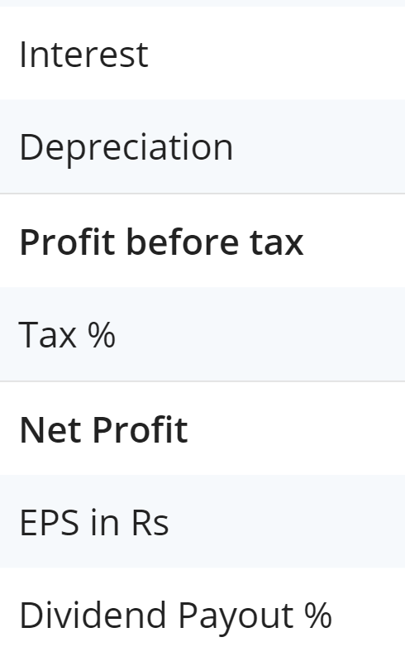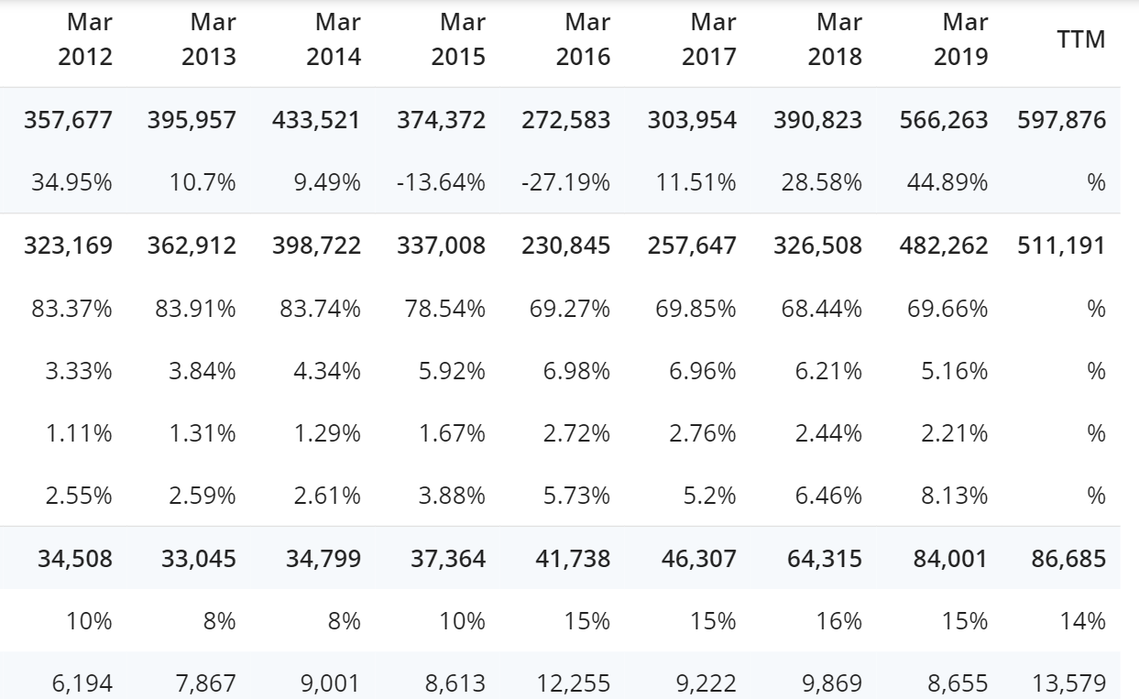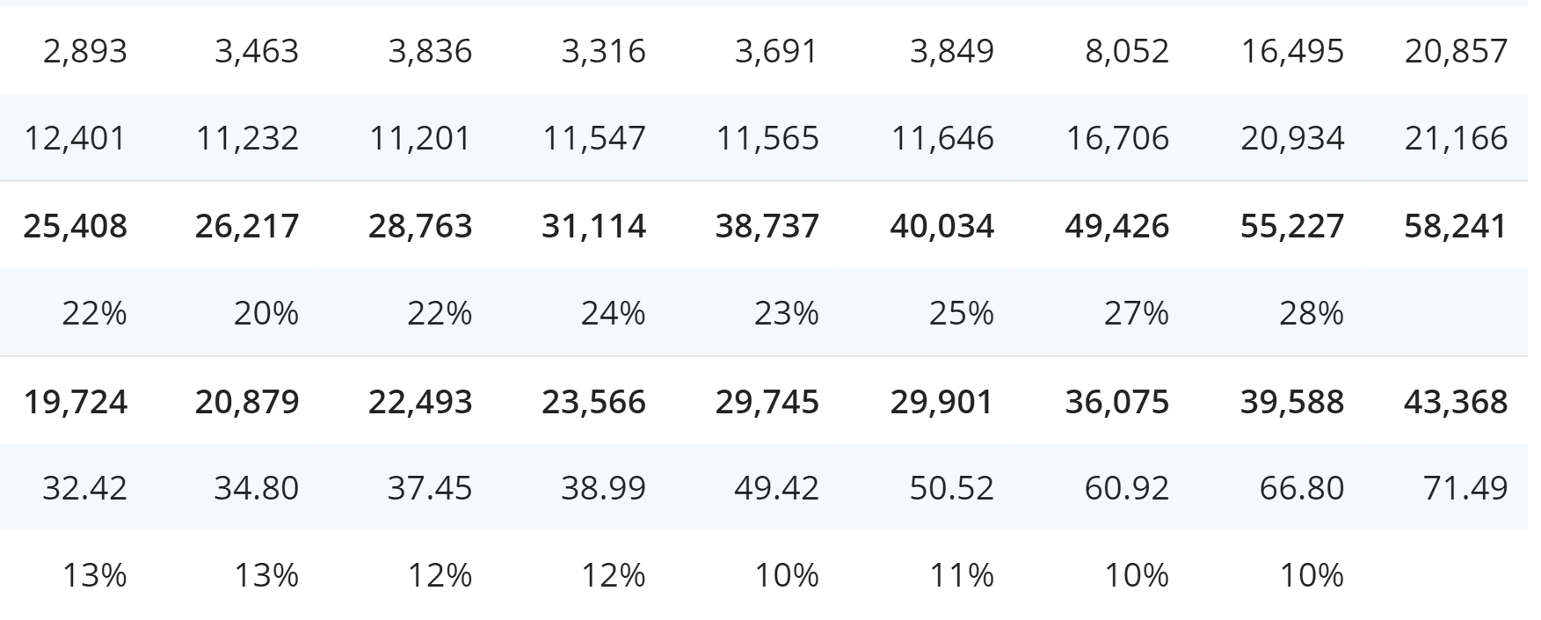

GOVERNANCE AND SAFETY:

Reliance’s governance standards are built on the foundation of systems that support transparency and ethical business conduct. In an effort to strengthen risk management and internal controls, Reliance instituted the Reliance Management System (RMS), designed to operationalise a harmonious work culture by codifying and embedding standardised processes into the DNA of every function. RMS has been further strengthened by leveraging the power of digitised platforms.



SUSTAINABILITY:

Reliance group was committed to making continuous improvements across the triple bottom line and enabling positive change in the society. Our ability to manage, utilise and transform the six capitals – Natural Capital, Human Capital, Manufactured Capital, Intellectual Capital, Financial and Social and Relationship Capital – is the key to creating value for our stakeholders. In our continued pursuit of excellence, noteworthy capital investments were undertaken, which led to reduction of carbon emissions and enhancement of resource efficiency. We are committed to becoming a leader in the emerging circular economy and becoming one of the largest recyclers of plastics in India.

AWARDS AND ACCOLADES:

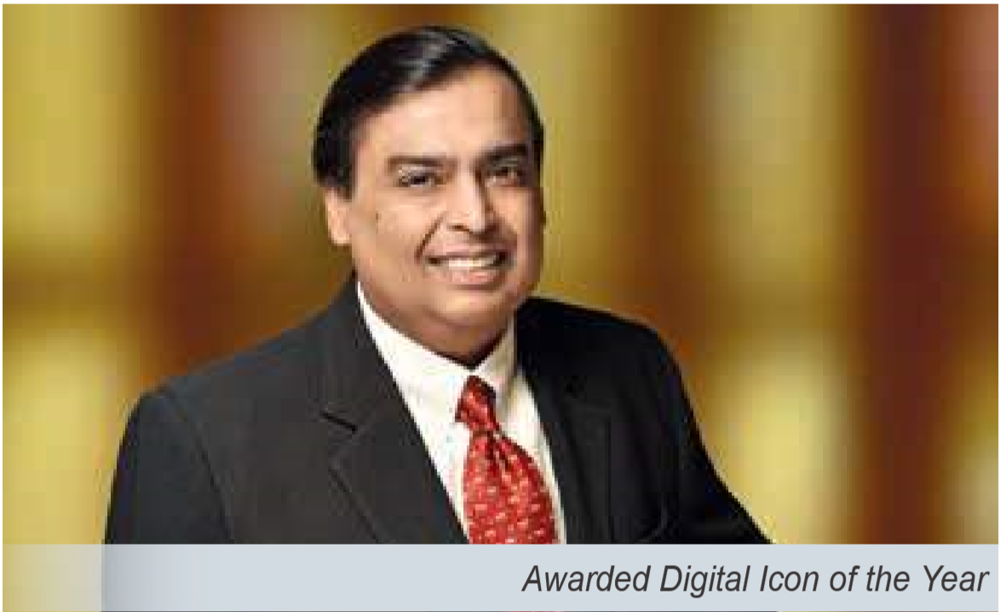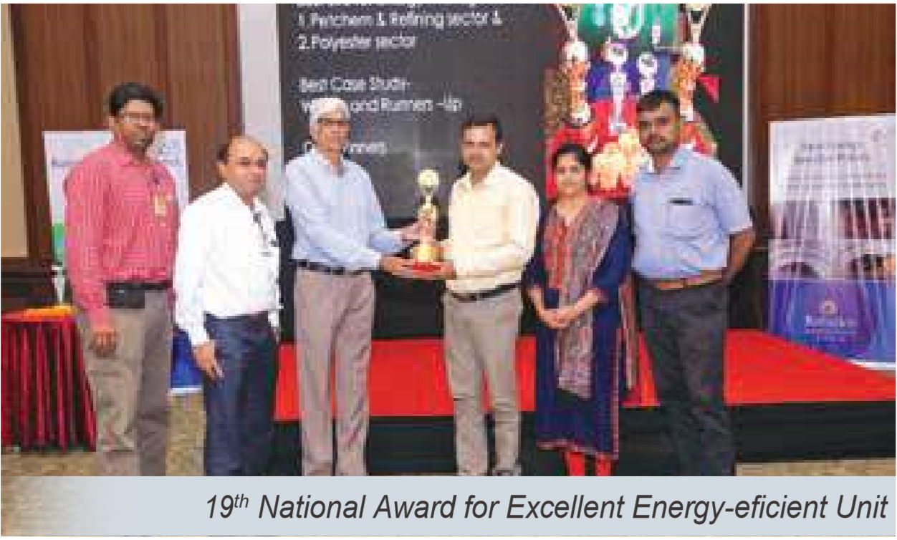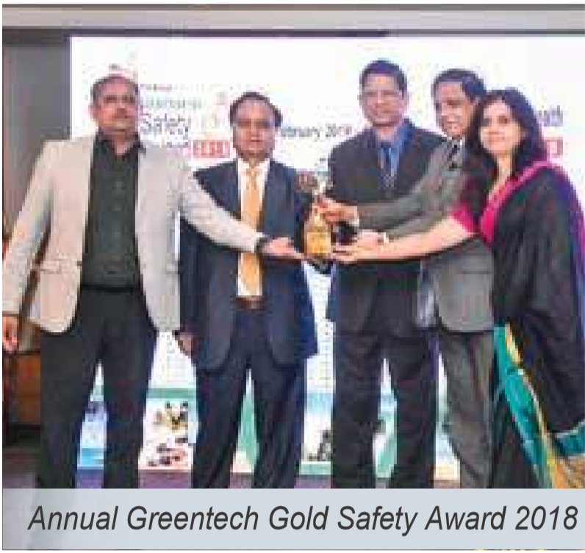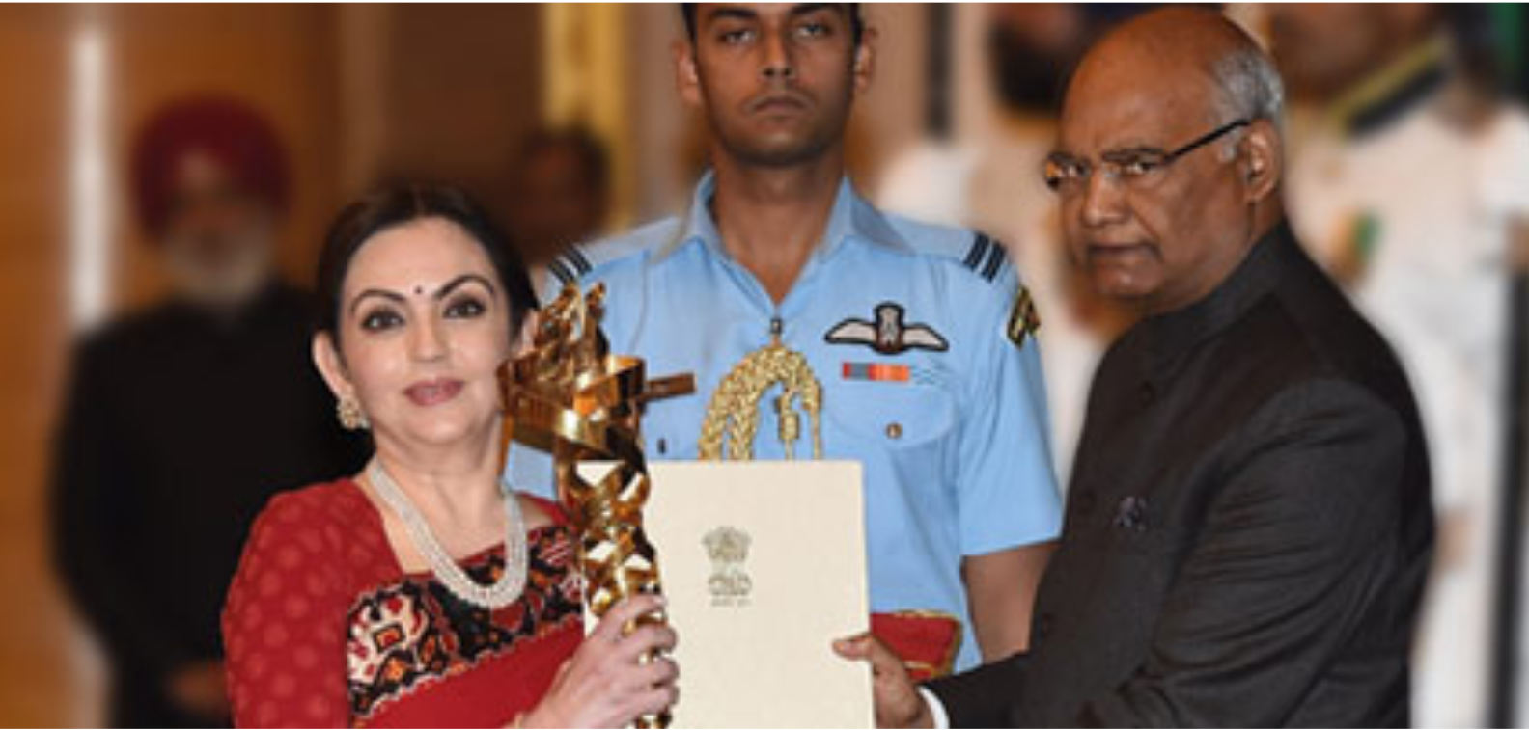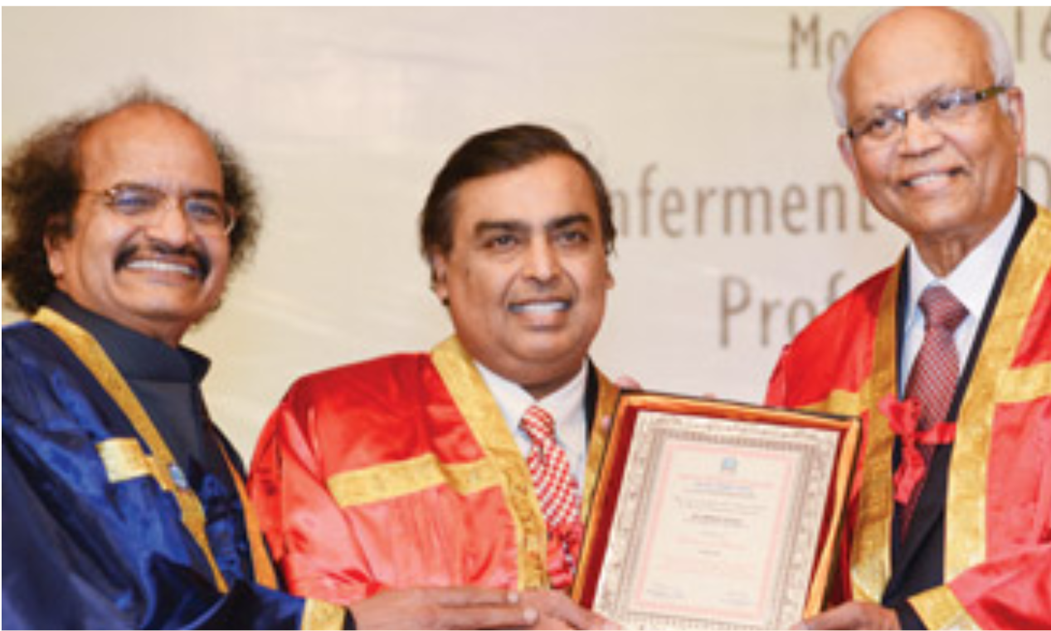

RELIANCE FOUNDATION:

 Reliance Foundation was instituted with a vision to build a stronger and inclusive India. CSR activities of RIL are carried out under the umbrella of Reliance Foundation. Led by Smt. Nita M. Ambani, Reliance Foundation has a comprehensive approach towards the nation's development. With the aim of building better lives and improving the livelihood of the people for a stronger and inclusive India, the Foundation addresses some of India's most pressing development challenges.

REACHED TO:

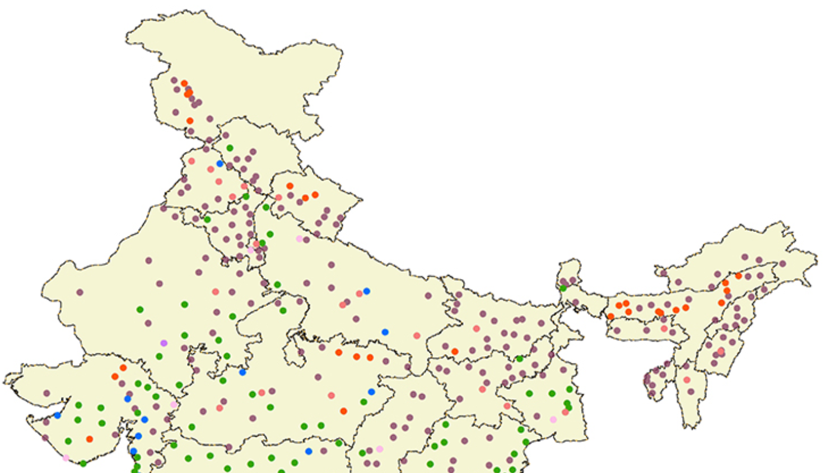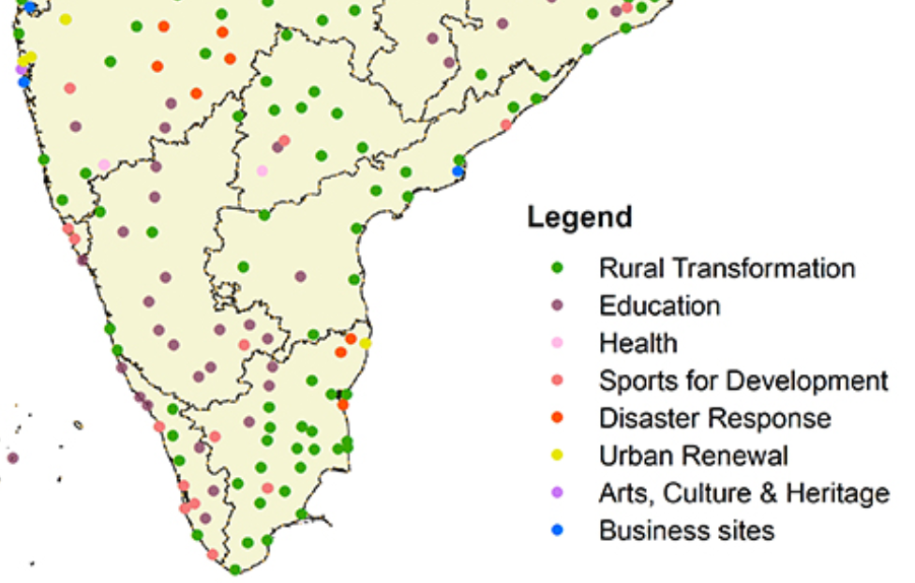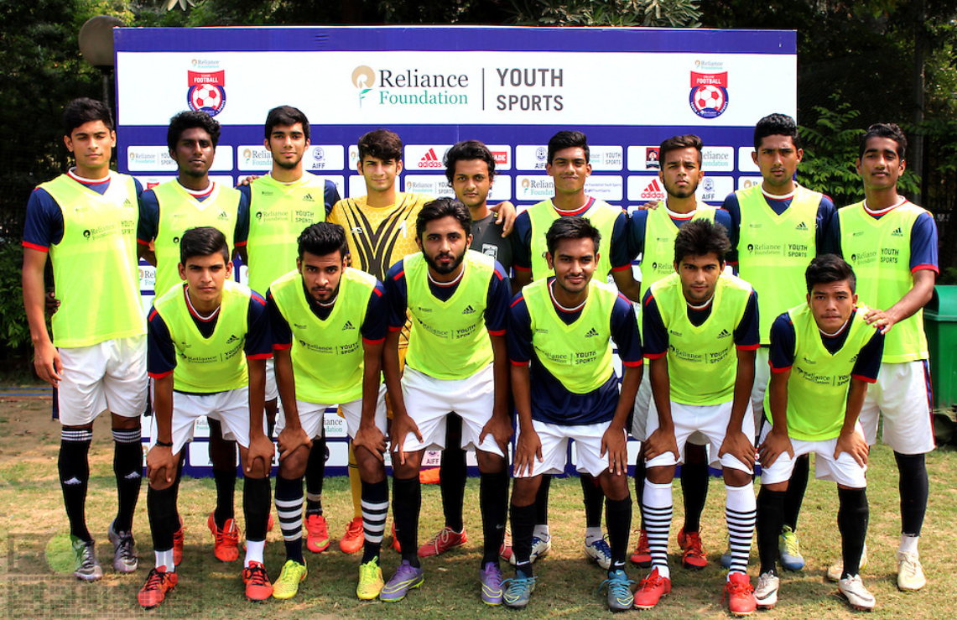

Mukesh Ambani donates additional Rs 500 cr to PM's emergency fund:   
 Billionaire Mukesh Ambani on Monday gave an additional Rs 500 crore to the Prime Minister Narendra Modi's PM-CARES Fund on top of the multi-crore initiative of the country's first COVID-19 hospital as he leads the Indian industry in pledging resources to fight the crisis.   
 Ambani's Reliance Industries said that besides donating Rs 500 crore to the the PM-CARES Fund, it will also provide Rs 5 crore each to the governments of Maharashtra and Gujarat to support their fight against the coronavirus pandemic

These are in addition to the 100-bedded dedicated coronavirus hospital in Mumbai, manufacturing 1 lakh protective face masks per day, 50 lakh free meals to the needy through non-governmental organisations (NGOs) and fuel to emergency vehicles carrying Covid-19 patients.

Scams:

 Five main allegations concerning Reliance, and which have plunged the Indian capital markets into a period of uncertainty unsurpassed since the days of the securities scam were:

* Reliance issued fake shares.
* It switched shares sent for transfer by buyers to make illegal profits.
* It has indulged in insider trading in shares.
* It established a nexus with the Unit Trust of India to raise huge sums of money to the detriment of UTI subscribers.
* It attempted to monopolise the private telecom services market through front companies.

### Insider trading

Stock market fraud regulator Securities and Exchange Board of India (Sebi) issued a show-cause notice to Reliance Industries Ltd. following a probe into alleged insider trading in Reliance Petroleum Ltd (RPL) shares in November 2007.  probed transactions by entities that participated in and led to some three months of speculative rally after which the RPL stock surged to an all-time intraday high of Rs295 on 1 November 2007. In a separate and independent investigation related to the same issue, the income-tax (I-T) department looked at possible tax evasion by a dozen entities that Mukesh Ambani-owned RIL acknowledged to be its “agents”.

In Jan 2011, Sebi barred Anil Ambani and four other officials of Reliance Group—until recently known as the Reliance-Anil Dhirubhai Ambani Group (R-Adag)—companies from investing in listed shares until December 2011. Two group firms, Reliance Infrastructure Ltd (R-Infra) and Reliance Natural Resources Ltd (RNRL) were barred from making such investment until December 2012. According to Sebi's investigations, R-Infra and RNRL were prima facie responsible for misrepresenting the nature of investments in yield management certificates/deposits, and the profits and losses in their annual reports for the fiscal years 2007, 2008 and 2009. It also found misuse of FII regulations. The then minister of state for finance Namo Narain Meena, on 1 December 2009, in a written response to a query raised in the Upper House of Parliament, said that three firms of R-Adag—R-Infra, RNRL and RCom—had violated overseas debt norms. These end-use violations were observed by the Reserve Bank of India (RBI) regarding two ECB transactions—of $360 million and $150 million—by R-Infra.

### NICL

The Central Bureau of Investigation (CBI) filed a chargesheet in a Mumbai court against Reliance Industries Limited (RIL) and four retired employees of National Insurance Company Limited (NICL), including a former CMD, under provisions of the Prevention of Corruption Act for criminal conspiracy and other charges. Acting on a reference from CVC in March, 2005, the CBI started probing the conspiracy that led to the filing of the chargesheet on December 9, 2011. The 2005 complaint had alleged irregularities in issuance of insurance policies — for coverage of default payments — by NICL to RIL. Chargesheet also mentioned criminal offences with dishonest intention and causing wrongful loss totaling Rs 147.41 crore to NICL and wrongful gain to the private telecom provider.

Two retired senior officials of National Insurance Company Limited and 11 others were awarded varying jail terms by a Delhi court in Jan 2014.

### RIL plane grounded

A business jet owned by Reliance Industries (RIL) was grounded by The Directorate General of Civil Aviation (DGCA) on 22 March 2014 during a surprise inspection, for carrying expired safety equipment on board; its pilot was also suspended for flying without a licence.

### ONGC controversy

In May 2014, ONGC moved to Delhi High Court accusing RIL of pilferage of 18 billion cubic metres from its gas-producing block in the Krishna Godavari basin.Subsequently, the two companies agreed to form an independent expert panel to probe any pilferage.

### Krishna Godavari (KG) Basin gas

The Reliance Industries Limited (RIL) was supposed to relinquish 25% of the total area outside the discoveries in 2004 and 2005, as per the Production Sharing Contract (PSC). However, the entire block was declared as a discovery area and RIL was allowed to retain it. In 2011, the Comptroller and Auditor General of India (CAG) criticized the Oil Ministry for this decision. The CAG also faulted RIL for limiting the competition in contracts, stating that RIL awarded a $1.1 billion contract to Aker on a single-bid basis.

### Petition against Reliance Jio

A PIL filed in the Supreme Court by an NGO Centre for Public Interest Litigation, through Prashant Bhushan, challenged the grant of pan-India licence to RJIL by the Government of India. The PIL alleged that RJIL was allowed to provide voice telephony along with its 4G data service, by paying an additional fees of just INR16580 million (US$280 million) arbitrary and unreasonable, and contributed to a loss of INR228420 million (US$3.8 billion) to the exchequer.